JIL Vendor Management System (VMS)
System Overview
The Jagatjit Industries Limited Vendor Management System (VMS) is a professional, mobile-first platform designed to streamline the vendor onboarding and take it towards digital onboarding of vendors which leads to better process and collaboration among vendors and internal teams.
It ensures transparency, data integrity, and efficiency across multiple internal teams. It is a workflow based system, which helps to keep the master data thereby keeping the digital footprints.
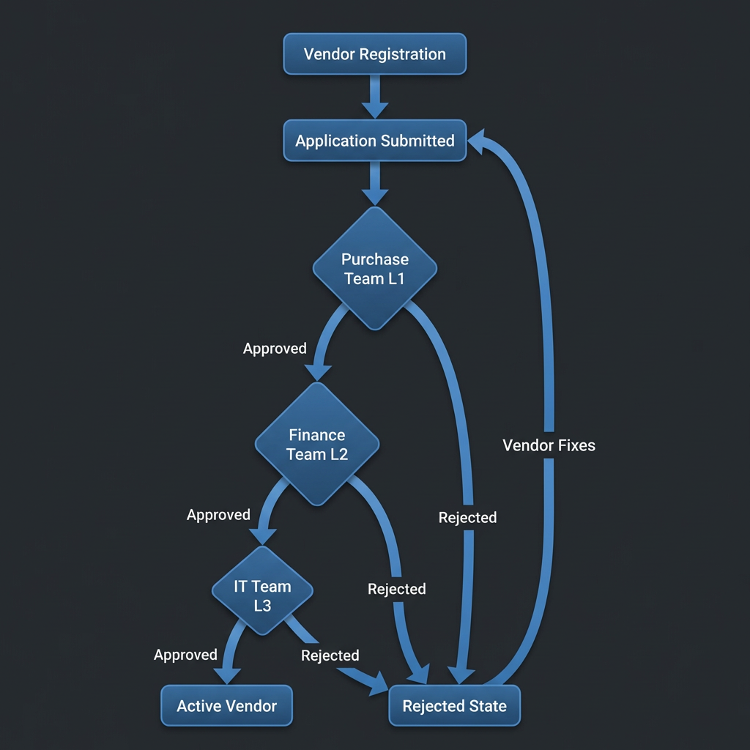
Core Architecture & Roles
The system is built on a secure PHP/MariaDB foundation with a Role-Based Access Control (RBAC) model and a Mobile-First Responsive UI.
1. User Roles
Role | Responsibility
Vendor | Submit business details/documents
Purchase (L1) | Initial screening of new registrations. Can Approve (to L2) or Reject.
Finance (L2) | Financial verification (Bank/PAN details). Can Approve (to L3) or Reject.
IT Team (L3) | Technical/Final verification. Can Approve (Activate) or Reject.
Administrator | System configuration, staff user management, and bulk vendor imports.

Vendor Lifecycle
1. Vendor Creation, Email Trigger & Onboarding Submission
- Vendor account is created in the system with Email ID and password.
- Automatic email is sent to the vendor immediately upon creation, containing:
  - Secure login credentials (Email ID + password)
  - Direct link to the vendor onboarding form
  - Instructions to complete and submit the onboarding details
- Vendors access the website link, completes the multi-step onboarding form via the link.
- Captured data includes:
  - Business Contact Information
  - Bank Details
  - Statutory Information (PAN / GST)
- Once submitted, the application automatically enters the verification pipeline.

2. Multi-Level Approval Pipeline
- Parallel Monitoring
  - All internal staff teams can view the master vendor list.
  - Only the team assigned to the current approval level (L1, L2, or L3) can act on pending applications.
- Search & Filter
  - Staff can search vendors by:
    - Company Name
    - Email
    - City
    - Application Number (App #)
3. Rejection & Remediation
- If an application is rejected at any stage:
  - The vendor is automatically notified within the vendor portal.

Key Technical Features
Premium User Experience
- Responsive Layouts: Fully functional on smartphones, tablets, and desktops.
- Smart Components: Hamburger menus for small screens and sticky sidebars for desktops.
Admin Control Center
- Unified Management: Admins can manage both internal staff and vendors from a single "User Management" dashboard.
- Bulk Operations: Admins can import hundreds of vendors instantly using a standard CSV template, automatically generating secure accounts for them.
- Optimized Queries: Paginated tables and efficient SQL UNION logic to handle large datasets smoothly.

